MASCHERPA Audric ROB 3 2022 / 2023

**POLY-SNAKE**

**Weekly report n°15 from 07/03/23 :**

Due to a printing problem, the 3D pieces could not be collected during this session. Thus the first tests in relation to the movements of the snake with wheels have been postponed until next week.

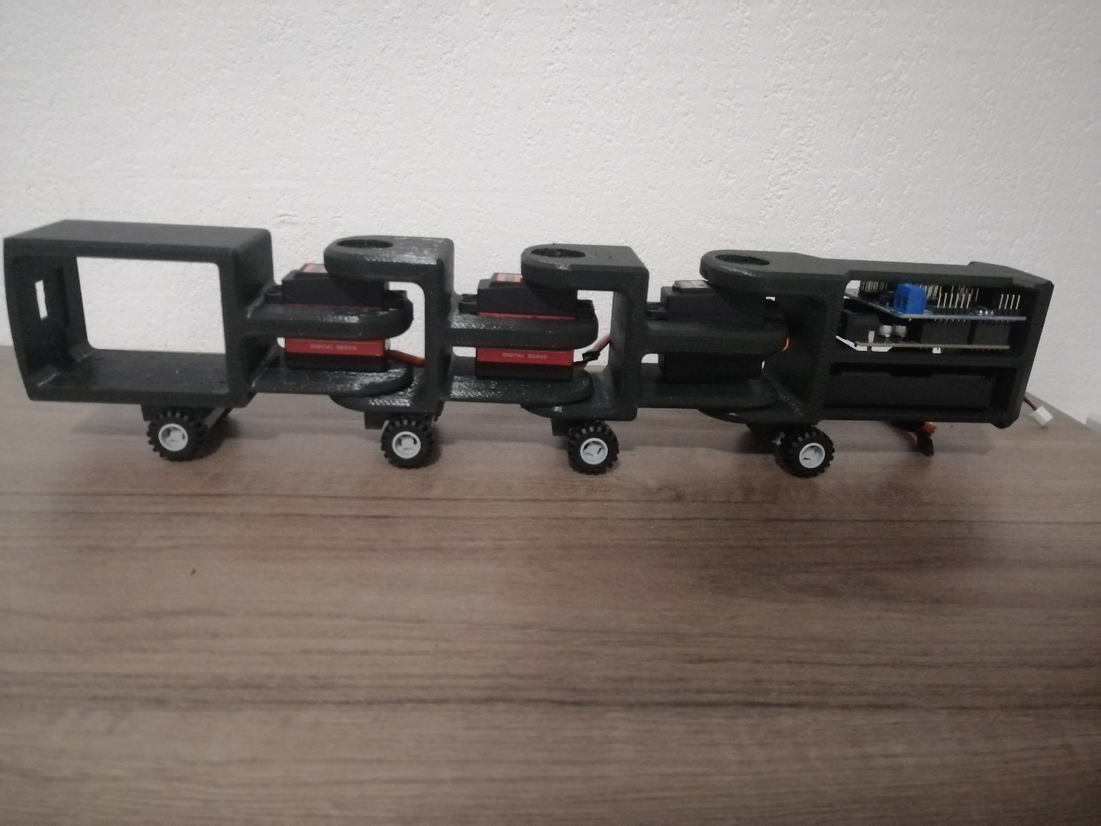However, we can see in figure 15.1 part of the 3D printing of the snake's body made at the end of the week after the project session.

Figure 15.1

We can see on the left the head of the PolySnake which will contain the raspberry nano card as well as the camera and on the right the tail containing the battery and the Arduino card.

then, during the rest of this session, in order to help my partner in programming the raspberry nano card, research was carried out in order to program color and shape recognition. The ultimate goal is to allow our project to navigate in space using the red arrow as in Figure 15.2.

Figure 15.2

So here are the links to youtube videos explaining how raspberry cards and

their camera work:

<https://www.youtube.com/watch?v=mNjXEybFn98>

<https://www.youtube.com/watch?v=-ZyFYniGUsw>

<https://www.youtube.com/watch?v=qfbPZbyYv8A>

This video explains :

* The imports of important packages such as CV2
* Create ours trackbars
* Setting up the raspberry camera
* The PiRGBarray
* Setting up the color recognition

So the next session will be devoted to testing the movements of the snake with wheels and programming the card and the raspberry nano camera using OpenCV